12 Bar Blues Riff

1) Play the chord chart through
2) Practice this riff in the 3 different positions shown
3) Move the riff according to the chord chart

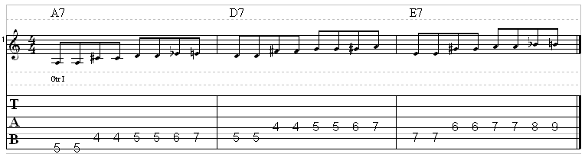

A7 | A7 | A7 | A7
D7 | D7 | A7 | A7
E7 | D7 | A7 | A7

